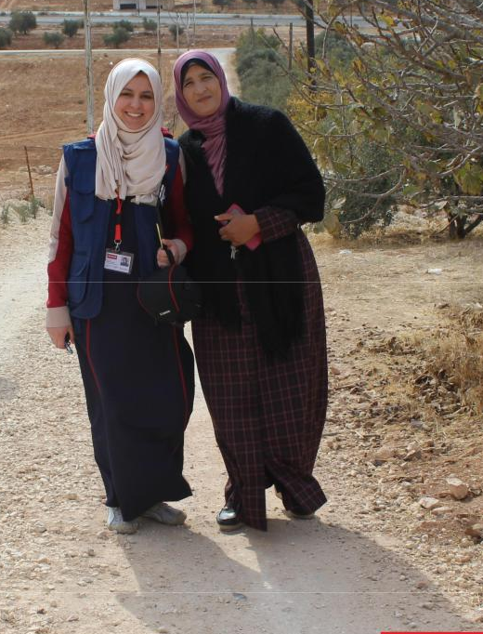

Factors influencing the livelihood projects in Medair (INGO) in Jordan projects
Date: January, 2019

Authors: Darine Abu Sa’adah

Contents

1. ABSTRACT 2

2. INTRODUCTION 2

3. OBJECTIVES OF EVALUATION 3

4. METHODOLOGY 4

5. FINDINGS 5

5.1 QUALITY OF PROGRAM DELIVERY 5

5.2 IMPACT ON PARTICIPANTS’ BUSINESSES 9

5.3 THE SUSTAINABILITY OF BUSINESSES 13

6. CONCLUSIONS AND LESSONS LEARNT 14

7. CASE STUDIES 16

1
1. ABSTRACT

Since the Syrian crisis began in 2011, over 650,000 registered refugees have fled to Jordan and are now residing in the country. Jordan has stretched its resources to accommodate this huge influx and a 10% increase in its population. This has resulted in enormous political, social and economic pressures. The welcoming of refugees has raised the cost of rent and goods far beyond pre-crisis levels and the need for Jordanians to find employment is ever more crucial.

As the chart below demonstrates, in the past five years the percentage of unemployment in Jordan has risen, with a spike in unemployment occurring in the last two years. Additionally, Jordan has one of the largest gender disparities in the world, with 25.2% of women unemployed, compared to 13.8% men in 2016¹.
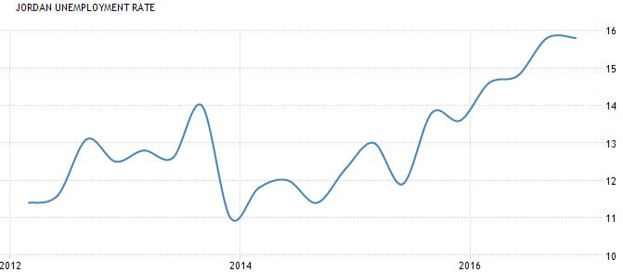

Figure 1: source: www.tradingeconomics.com / Department of Statistics, Jordan

While government jobs comprise approximately 35% of the formal workforce in Jordan, it is the private sector firms - particularly start-ups - that offer the greatest opportunities for job creation. Currently, SMEs make up 95% of the national economy in Jordan. Among key national priorities for the coming years is a focus on empowering small to medium sized enterprises (SMEs) to curb unemployment and poverty. In 2016, SMEs contribute to employing around 70 per cent of the private sector's workforce².

2. INTRODUCTION

In April 2017, Medair conducted a local partner selection process and chose Jordan Education for Employment (JEFE) and Near East Foundation (NEF) to implement livelihood programs that would build the capacity of Jordanian entrepreneurs to either initiate or expand their businesses. The project targeted vulnerable Jordanians in Mafraq and Irbid with low financial incomes, who had the idea,

- Trading Economics, http://www.tradingeconomics.com/jordan/unemployment-rate

- http://www.jordantimes.com/news/business/workshop-tackles-financing-smes

2

ambition and acumen to develop a business to generate income. While the partners were given flexibility in their approaches, both programs consisted of:

- Identification of participants through outreach events, referrals from local Community Based Organisations (CBOs) and interviews for selection

- Entrepreneur training by a specialist trainer (five to 10 days) and guidance on writing business

plans

Following the partners review of business plans, selected participants went on to receive:

- Vocational training specific to their business or advanced marketing training

- Cash grants of between 70 and 700 JOD depending on the business

- Follow up coaching and mentoring or networking groups

- Setup bazaars for participants to showcase and sell their products or services

Medair’s support was split into two phases, from May 2017 to October 2017, and then from November 2017 to October 2016. This evaluation paper considers both the participants who started in phase 1 and who have been supported for up to 18 months and those that entered the program in phase 2. Across both phases,194 households were reached in total.

 |  |  |  | JEFE |  | NEF
 | Total Number of participants |  | 115 |  | 79
 | Number of beneficiaries who received grant |  | 72 |  | 71
 | Grant amount range (JOD) |  |  | 200 to 700 |  | 70 to 350
 | Gender |  |  | 100% female |  | 100% female
 | Governorate |  |  | Irbid: 53% |  | Irbid: 73%
 | Governorate |  |  | Mafraq: 47% |  | Mafraq: 27%
 | Age range (years) |  |  | 19 to 43 |  | 24 to 72
 | New/existing businesses |  |  | New: 83% |  | New: 29%
 | New/existing businesses |  |  | Existing: 17% |  | Existing: 71%

- METHODOLOGY

JEFE and NEF were responsible for the implementation of their projects,During the assessment of the program, Medair contacted participants directly and independently of the partners. The assessment took place in November 2017, using quantitative and qualitative research methods. Adopted methods included household visits, telephone interview survey, focus group discussions with participants and semi-structured interviews with the partners and Medair’s field staff.
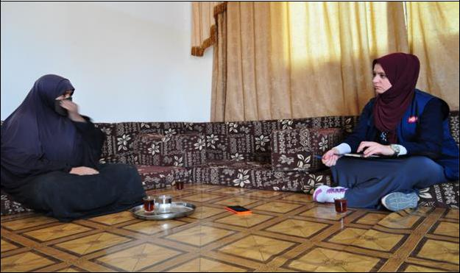

Medair conducted house visits in Mafraq and Irbid

Household Visits: 10 businesses have been visited (five from JEFE and five from NEF) to gain an understanding of how the businesses are operating and the level of impact.

4

Telephone Interview Survey: To provide quantitative results of programmatic impact, telephone interviews were conducted with 112 households ensuring those included were not in household visits or focus group discussions.

Focus Group Discussions: To gain an in-depth understanding of the impact of the livelihood support on the participants, focus group discussions were conducted. Four focus group discussions took place (two for each partner, split by Mafraq and Irbid). Between five and 11 participants were targeted, with table below summarising the participants:

 |  |  |  |  |  |  |  |  |  | JEFE |  |  |  |  |  |  |  |  |  |  |  | NEF
 |  |  |  | # of B |  |  | Age |  |  | Marital |  |  | Education |  |  | # of B |  |  | Age |  |  | Marital |  |  | Education
 |  |  |  | # of B |  |  | Age |  |  | Status |  |  | Education |  |  | # of B |  |  | Age |  |  | Status |  |  | Education
 |  |  |  |  |  |  |  |  |  |  |  |  | 1 Master |  |  |  |  |  |  |  |  |  |  |  | 1Bachelor
 | Irbid |  | 9 |  |  | 21-35 |  |  |  | 7 single |  |  | 5 Bachelor |  | 5 |  |  | 45-56 |  |  |  | 3 married |  |  | 1 diploma
 | Irbid |  |  |  |  |  |  |  |  | 2 married |  |  | 3 secondary |  |  |  |  |  |  |  |  | 2 widowed |  |  | 3 secondary
 |  |  |  |  |  |  |  |  |  |  |  |  | school |  |  |  |  |  |  |  |  |  |  |  | school
 |  |  |  |  |  |  |  |  |  | 3 single |  |  | 2 Bachelor |  |  |  |  |  |  |  |  |  |  |  | 4 secondary
 |  |  |  |  |  |  |  |  |  |  |  |  | 1 diploma |  |  |  |  |  |  |  |  | 2 married
 | Mafraq |  | 11 |  |  |  | 22-41 |  | 7 married |  |  |  |  |  | 5 |  |  | 35-41 |  |  |  |  |  |  | school
 | Mafraq |  |  |  |  |  |  |  |  |  |  |  | 8 secondary |  |  |  |  |  |  |  |  | 3 widowed
 |  |  |  |  |  |  |  |  |  | 1 widowed |  |  |  |  |  |  |  |  |  |  |  |  |  |  | 1 Primary school
 |  |  |  |  |  |  |  |  |  |  |  |  | school

Semi-structured Interviews: Following the results of the telephone interview, house visits and focus group discussions, the collected data was verbally shared with JEFE and NEF to comment on any results, and also to gain their perceptions of the project impact and any lessons learnt. On a similar basis, an interview was conducted with Medair’s livelihoods officer who was present at many of the activities conducted by the partners.

5. FINDINGS

5.1 QUALITY OF PROGRAM DELIVERY

i. Beneficiary Selection

From the database of beneficiaries provided by partners, 39% of businesses existed prior to the program with an aim to further develop their business, while 61% were newly established by participants during the program duration. JEFE and NEF varied greatly in their approach, with NEF selecting far more participants that had existing businesses (71%) compared to JEFE (17%). The types of businesses adopted were essentially ‘home businesses’, with the chart below illustrating the range of businesses.

5

Industries of businesses - partner comparison

Animals
Food
Handcrafts
Clothes
Agricultural
catering |  |  |  |  |  |  |  |  |  |  |  |  | NEF
Sewing |  |  |  |  |  |  |  |  |  |  |  |  | JEFE
Beauty
Accessories
hygiene tools
Other
0% |  | 5% |  | 10% |  | 15% |  | 20% |  | 25%
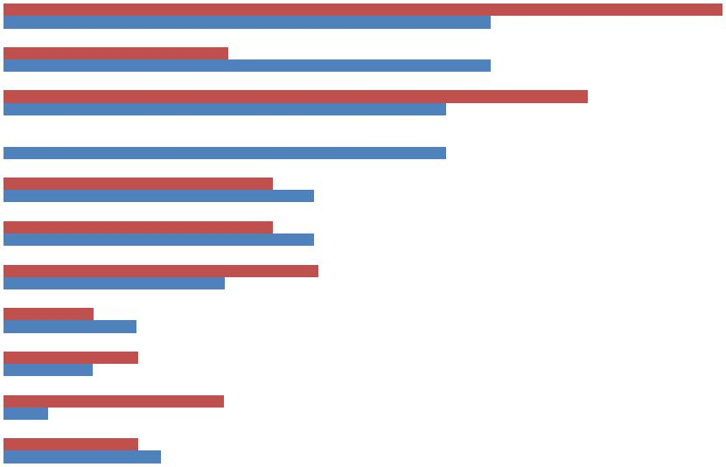

When selecting each participant JEFE and NEF proposed to use the criteria:

1- Living in vulnerable communities for at least two years
2- Individual income must be less than 70 JOD
3- Families have five or more members
4- Family income cannot exceed 400 JOD

During Medair’s visits to households it was clear that NEF had selected vulnerable cases and identified women who showed the capacity to enter the program. It was evident that JEFE’s participants were from more privileged backgrounds and had higher education levels. During the telephone interview results, participants shared their satisfaction levels with regards to the selection process, the results of which are shown below.
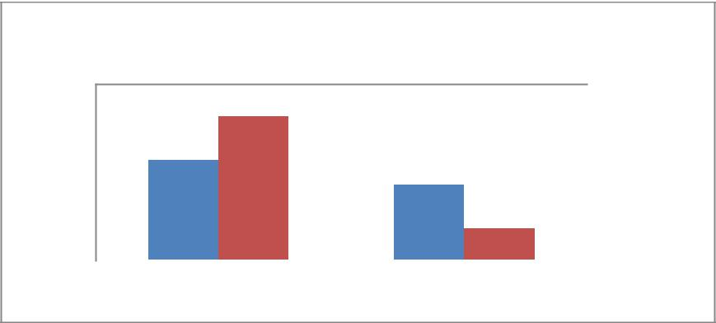

Satisfaction with the selection process

100%

50% |  |  |  |  | JEFE
0% |  |  |  |  | NEF
0% | Fair | Unfair

JEFE participants claimed that some of those selected had a healthy financial situation while other vulnerable women were not selected. JEFE since fed back that they selected beneficiaries based on satisfying one or more of the above criteria rather than satisfying all of them. JEFE’s past experience has focussed more on youth employment or entrepreneurship, so targeting vulnerable cases through this project has presented them with a new demographic. During the first phase, NEF committed to visiting 30% of households prior to selection. JEFE did not have this requirement; however in phase two Medair

6

made it mandatory for both partners that any new entries into the program must first receive a house visit.

As the chart below shows, NEF and JEFE were connected with CBOs to identify beneficiaries with JEFE also using social media as an outlet.
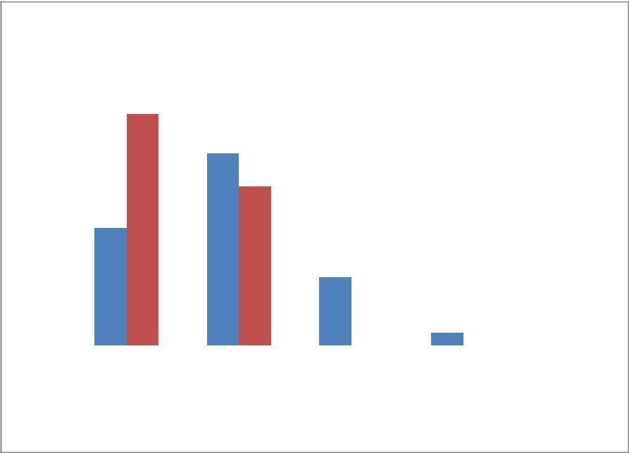

Methods of knowing about the program

70%
70% |  | 59%
60%
60% |  |  | 49%
50% |  |  | 49%
50% |  |  | 41%
40%
40% |  | 30%
30% |  |  |  |  |  |  | JEFE
30% |  |  | 17% |  |  |  | JEFE
20% |  |  | 17% |  |  |  | NEF
10%
10% |  |  |  | 3%
0%
0% |  | CBOs | Relatives,Social media | other
 |  |  | friends,

neighbors of
beneficiries

ii. Trainings

Both partners provided entrepreneur training for five to 10 days with the topics including marketing, budgeting, planning, pricing and how to form a business case. The results from the telephone interview verifies the attendance and demonstrates positive levels of satisfaction for the training itself, as detailed below.

 |  |  | JEFE |  | NEF
 | Participants who received |  | 98% |  | 94%
 | entrepreneur training |  | 98% |  | 94%
 | Satisfaction levels |  | 95% |  | 96%

 |  |  | JEFE | NEF
Participants | who | received
vocational | or | advanced | 68% | 95%
marketing training
Satisfaction levels |  |  | 92% | 100%

7

Satisfaction with training venue
98%
100%
80%
80% |  | 60%
60% |  |  |  |  |  |  |  | JEFE
60% |  |  | 40% |  |  |  |  | JEFE
40% |  |  |  |  |  |  |  | JEFE
40% |  |  |  |  |  |  |  | NEF
20% |  |  |  |  |  |  |  | NEF
20% |  |  | 2%
0%
 |  | Satisfied |  | Unsatisfied
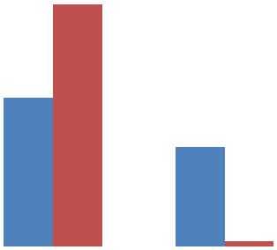

88% of the participants said the trainings played a major role in empowering them to generate income, as well as making connections to the other business women that participated. All participants stated that the trainers were well qualified. As reflected in the chart, 40% JEFE’s participants were not satisfied with the training location, particularly in Irbid where they reported that it was small, hot and crowded. Both partners provided transportation allowance to the participants to allow them to attend the trainings.
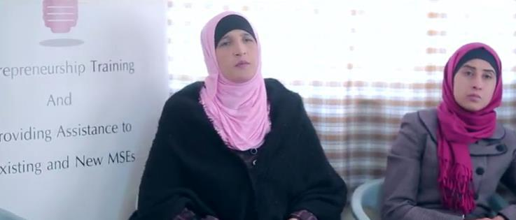

iii. Cash Grants

Based on the data sheet received from the partners, 309 beneficiaries benefited from Medair’s livelihood support (115 JEFE, and 79 NEF). Of these, 143 had received cash grant (72 JEFE and 71 NEF). JEFE provided the cash as a fixed amount for all businesses (500 JD in phase one and 200 JD in phase two) whereas NEF varied the size of their cash grant according to the business idea and needs. While giving a fixed amount can be seen as more fair amongst participants themselves, during household visits it was clear that using a variable amount was more successful as participants were able to purchase the equipment or resources needed to begin or kick-start their business. In some of the instances with a fixed amount, the business had yet to develop as the participant still could not afford the resources they needed.

Participants typically used the grant to purchase basic materials or equipment to increase the capacity of their production. Over 60% of the participants reported that they could not start their project without

Medair’s financial support.

5.2 IMPACT ON PARTICIPANTS’ BUSINESSES

The telephone interview consisted of 112 participants, of which 92 had received a cash grant from the program. A key finding is that all 20 that did not receive a cash grant reported that their businesses were not functioning at the time of the survey. It is likely that there is truth behind the correlation of cash grants and successful businesses (due to the cash grant itself, and the fact that grants were only given to the businesses that were mostly likely to succeed according to their business case). However, for 100% of businesses to fail is particularly high, and it is possible that respondents also gave this answer out of hope that it would result in a cash grant being given in the future.

76% of participants reported in the telephone survey that the support had a positive influence on their life. During the focus groups, they expressed the added income helped them to cover their basic needs, especially widowed women who often have little other income. They used the income to pay house rent, water and electricity invoices, meet children’s needs, general house expenses and a few of them used the money to pay for labours who then provided support to their business.

The following chart shows the level of income that participants generated through their businesses on a monthly basis. These results are based only on those who received cash grants, given it’s recorded that only businesses who received a cash grant went on to generate income.

9
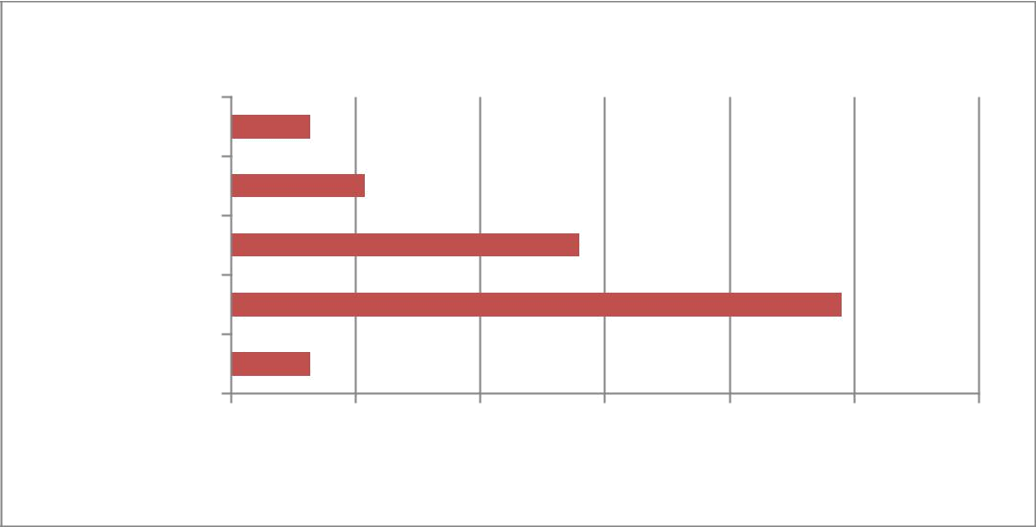
Monthly Income Generated

Monthly Income (JOD)

>300

200-300

100-200

<100

no income

0% 10% 20% 30% 40% 50% 60%

Percentage of businesses

Additionally, 60% of participants in the interview survey reported that they increased their incomes through their businesses. In terms of their target market, most of these home businesses are reliant on neighbours, family and friends as becoming their customers, as the chart below demonstrates:


Areas that participants used to sell their products

80%
80% | 67%
60%
40%
40% |  | 18%
20% |  | 18%
20% |  |  | 6% | 5% | 3% | 1%
0%
0% | Friends and | Government | Social Media | public | Bazars and | Restaurants
 | relatives and | institutions and |  |  | exibitions
 | neighbors | schools

The below chart shows a difference of the income generated according to which partner had implemented the program. Overall NEF beneficiaries result in a higher monthly income than JEFE beneficiaries. This is interesting given that NEF beneficiaries were perceived to be far more vulnerable than JEFE’s and less educated. During focus group discussions and interviews, there are a number of possible reasons given to explain this; NEF beneficiaries appeared to be more motivated for their businesses to succeed given they were more in need of generating income for their household. Additionally the quality of NEF’s program has been higher regarding the quality of training, variable cash grants and close follow-up and accountability of beneficiary at household level. Thirdly, NEF targeted a far higher percentage of beneficiaries that had existing businesses (71% of NEF’s participants) that were developed compared to JEFE (at 17%). Where businesses have already been able to stay active and sustained, they are often in a better position to thrive compared to the high risk nature of starting a business for the first time.

10

Percentage of Businesses

Income generated - partner comparison
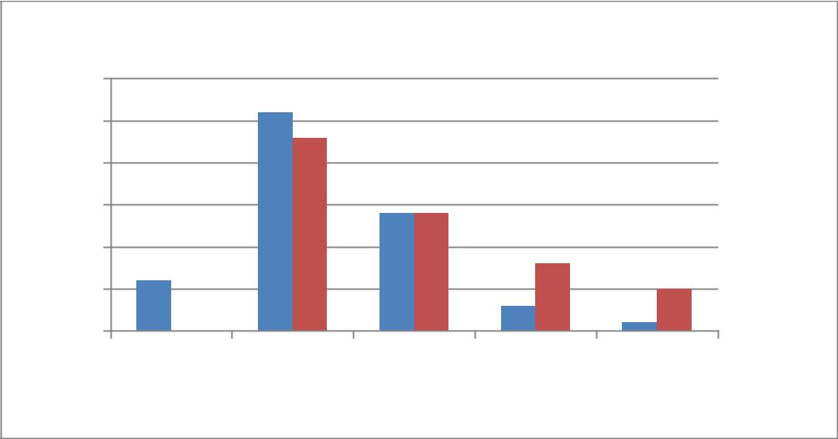

60

50

40

30
JEFE
20
NEF
10

0

no income | <100 | 100-200 | 200-300 | 300+

Monthly Income (JOD)

The chart below compares the income generated according to the governorates of beneficiaries. Irbid is a substantial city in Jordan with a population of over one million residents. The city of Mafraq is far smaller, although it has more than doubled since the Syrian conflict began in 2011, with the population now standing at over 200,000. There are many villages outside of the city of Mafraq and some of the businesses included were from the villages, particularly businesses for farming crops and ranching. The level of income generated in Irbid is higher than that of Mafraq, however the majority of NEF’s beneficiaries resided in Irbid which could be a major contributing factor to this.
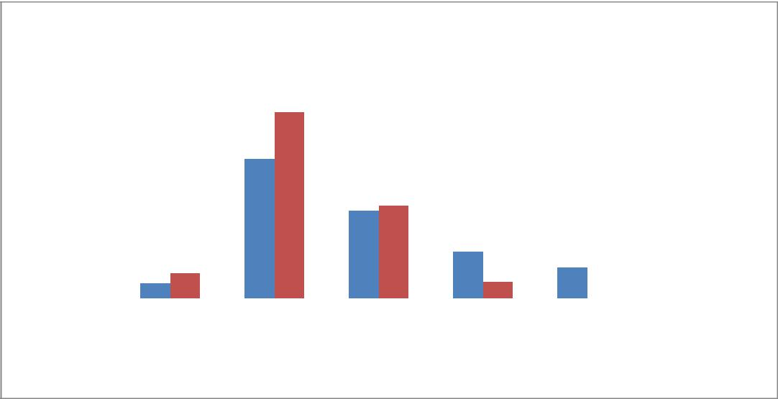

Percentage of Businesses

Income generated - governorate comparison

70%
60%
50%
40%
30% |  |  |  |  |  |  |  |  |  |  |  |  |  |  | Irbid
20% |  |  |  |  |  |  |  |  |  |  |  |  |  |  | Mafraq
10% |  |  |  |  |  |  |  |  |  |  |  |  |  |  | Mafraq
0%
 |  | no income <100 |  |  | 100-200 200-300 |  |  |  | 300+

Monthly Income (JOD)

11

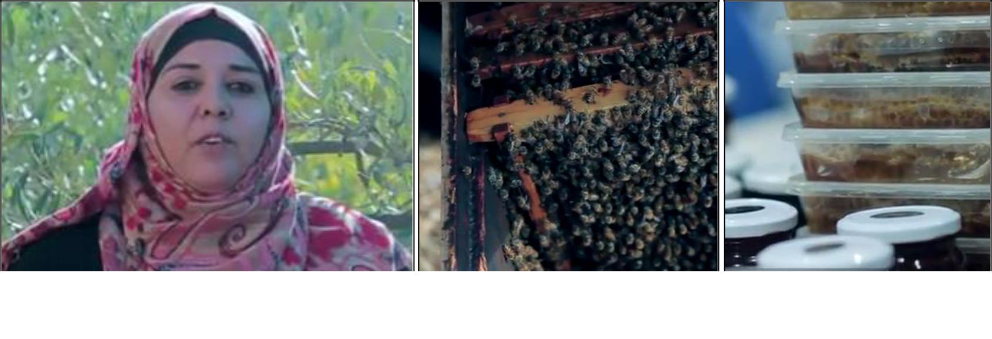

Asmahan from Irbid started a business in bee farming that produces honey and soap. She entered the programme through JEFE and was able to plan her own project with the help of the training.

The chart below analyses the income generated by comparing businesses that existed prior to the program and those that were setup for the first time. The results are from the sample that received cash grants only (92 people in the telephone interview). The results show a clear result that increased levels of income were generated by businesses that already existed. Further information is required from partners to know the level of income that existing businesses generated at the start of the project to measure the true extent of how much the existing businesses have developed and grown.
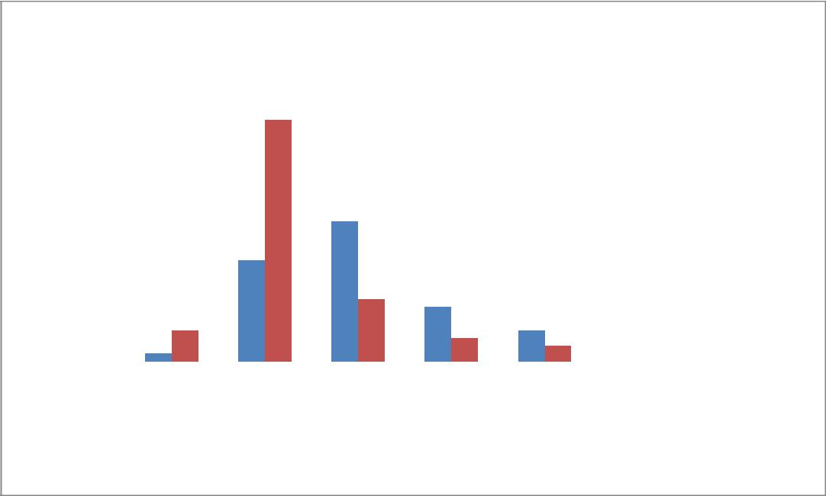

Percentage of ubsinesses

Income generated - existing vs new businesses

40%
35%
30%
25%
20% |  |  |  |  |  |  |  |  |  |  |  |  |  |  | Existing Business
15% |  |  |  |  |  |  |  |  |  |  |  |  |  |  | Existing Business
10% |  |  |  |  |  |  |  |  |  |  |  |  |  |  | New Business
5%
0%
 |  | no | <100 100-200 200-300 >300
 |  | income

Monthly Income (JOD)

The table overleaf details the monthly income generated by the different types of businesses. 100% of agriculture businesses resulted in 200-300 JOD; however this is misleading as there was only one agricultural project included in the telephone survey that received a cash grant. It is important to consider the total number of participants for each row. The data does suggest that businesses centred around sewing or convenience supplies generate less income, compared to the selling of clothes or food.

12

 |  |  |  | Total |  |  | no |  |  | <100 |  |  | 100-200 |  |  | 200-300 |  |  | >300
 |  |  |  | Total |  |  | income |  |  | <100 |  |  | 100-200 |  |  | 200-300 |  |  | >300
Accessories |  |  | 2 |  |  |  |  |  | 50% |  |  | 50%
Agriculture |  |  | 1 |  |  |  |  |  |  |  |  |  |  |  | 100%
Animals |  |  | 6 |  |  |  |  |  | 33% |  |  | 50% |  |  | 17%
Beauty |  |  | 13 |  |  |  |  |  | 53% |  |  | 31% |  |  | 8% |  |  | 8%
Clothes |  |  | 10 |  |  |  |  |  | 40% |  |  | 20% |  |  | 30% |  |  | 10%
Food |  |  | 22 |  |  |  |  |  | 45% |  |  | 32% |  |  | 9% |  |  | 14%
Convenience shop supplies |  |  | 11 |  |  | 18% |  |  | 46% |  |  | 27% |  |  | 9%
Handcrafts |  |  | 11 |  |  | 9% |  |  | 55% |  |  | 27% |  |  | 9%
Hygiene tools |  |  | 4 |  |  |  |  |  | 50% |  |  | 25% |  |  |  |  |  | 25%
Medical cosmetic products |  |  | 1 |  |  |  |  |  | 100%
Perfume | and | soap | 1 |  |  |  |  |  | 100%
installation
Sewing |  |  | 10 |  |  | 20% |  |  | 60% |  |  | 20%

 |  | the personality |  | situation

6. CONCLUSIONS AND LESSONS LEARNT

- Livelihood programs often require longer term support and investment to succeed, however the findings of the project conducted over the past 18 months have been encouraging. The volume of investment and level of attention provided by the partners has been positive, albeit the quality of results from one partner are higher than the other – this was also evident at the end of phase one, however it was important to continue the support to both partners and not abandon one set of beneficiaries. Instead Medair looked to provide JEFE with additional direction, guidance and feedback through the monthly management meetings held in Amman. While JEFE had not targeted the most vulnerable communities in their past work, they have gained substantial experience through this project that has led them to continue to this in the future and design programs that target Syrian refugees’ livelihoods in Jordan. Medair has been conscious and intentional about gauging its own level of involvement towards each partner during the implementation, realising that this can be adapted as necessary during the project.
- All beneficiaries selected were women; while there is a significant unemployment rate among women in Jordan it was not the intention or the requirement of the partners to select only women. Both partners fed back that very few applicants were received by men and that the applications received were not suitable. They added that from their experience it is typically women who see these opportunities and to partake and who are more motivated to make their small business succeed to supplement the family income.
- The level of income generated by participants was approximately 300JOD per business. This is unlikely to cover the costs of a household however for many families it can provide a vital contribution towards the household’s wider income. 76% of participants reporting that their businesses are currently generating income. This is higher than anticipated, however it is also noted, during home visits that the barriers to setup home businesses are not high. Registration is not required for home businesses and with a level of training, encouragement, finances and accountability it has been possible for participants to begin their work.

- There are some useful findings regarding the factors at play for successful businesses. For example, it is clear that businesses which were in existence prior to the program starting were more successful and beneficiary feedback clearly illustrated that variable cash grant sizes were preferred to fixed amounts. Additionally, no business continued to operate that did not receive a cash grant although it is unclear if there is information bias in the results in the hope of receiving a grant in the future. Expected good practice (household visits during beneficiary selection and follow-up) resulted in greater impact from the perspective of the beneficiaries. Additionally, during focus group discussions beneficiaries suggested that having more bazaars and exhibitions would provide an opportunity to showcase their work, make connections and invite feedback from the partners regarding their presentation of their goods and services.

